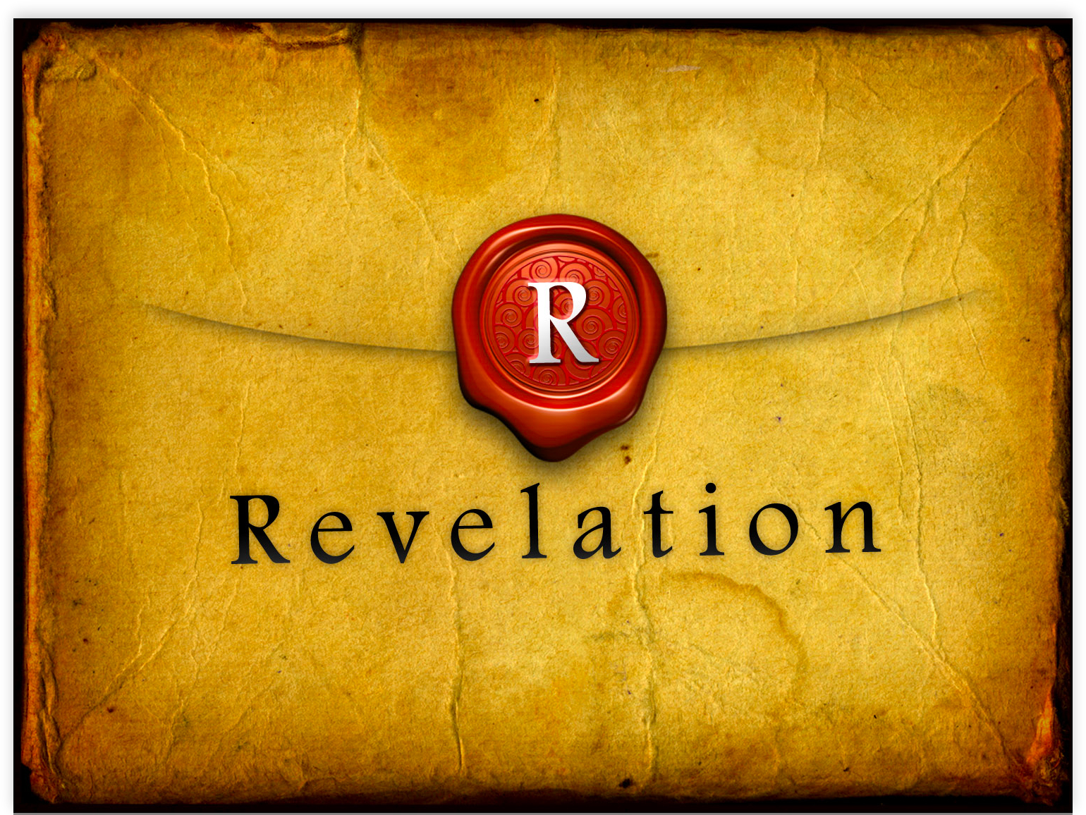

The 7 Letters
Letter of Preparations (2:1-3:22)

By Rev. Chad Trunkhill
July 23, 2017

Introduction
- Since Revelation is cyclical, the seven letter cover the same timeframe as the other “sevens” of Revelation
  - Seven seals
  - Seven trumpets
  - Seven censers
- This time frame covers between the period of Christ’s first and second advent.
- Yet different as their intent and purpose is to prepare the recipients for receiving and applying the message in the visions that begin in 4:1. (prepare and repent)
- While to specific churches – general message applies to all Christians of all times
- Heart of message is the danger each church faces
  - Can happen at any time or place
  - Threatens the very faith of the church/Christian
- Church must repent of their sins – stand firm in the faith
- End result of faithful is a promised blessing
- All 7 messages for all churches
- All churches under the care and love of Christ
- “angel” of each church is the stated recipient of each letter
- They are first mentioned in Rev. 1:20
  - Some believe they are bishops or pastors of churches
  - Some believe they are true angelic beings
  - Some view it as symbolic of the prevailing spirit of each church
- Taking all of Revelation into account – true angelic beings are the best interpretation
- Aggelos appears 67 times in Revelation and these would be the only cases where it is not a heavenly being if interpreted this way
- Common Elements of the Seven Letters
  - To:
  - Local Details:
  - Image of Christ:
  - What Christ Sees:
    - Good:
    - Bad:
  - Call To Repent:
  - Promise to the one who conquers:
- 7 refers to the sevenfold presence of the Spirit and the church under the control of the Spirit (entire church)
- 12 (and multiples thereof – 24, 144,000) represent the church of God as church
- 7 sins deal with temptation and following into further temptation to leave their “first love” for Christ (2:4).
- Awareness for our sinfulness and need for a godly repentance prepares us for the message of Revelation.
To the Angel of Ephesus
^{2:1} To the angel of the church in Ephesus write,
“These things says he who holds the seven stars in his right hand, the one who walks about in the midst of the seven golden lampstands: ²’I know your works and toil and your endurance, and that you are not able to bear evil people, and you have tested those who call themselves apostles and are not, and you found them to be liars. ³You have endurance and you bore up on account of my name and you have not grown weary. ⁴However, I have something against you, namely that you have left your first love. ⁵Remember then from whence you have fallen and repent and produce the first works. And if you don’t, I am coming to you and I will remove your lampstand from its place, if you don’t repent. ⁶But this you have, namely, that you hate the works of the Nicolaitans which I also hate. ⁷The one who has ears, let him listen to what the Spirit says to the churches. To the one who conquers I will grant to eat from the tree of life, which is in the paradise of God.’”

- To: Ephesus
- Local Detail: False apostles and Nicolaitans are there
- Image of Christ:
  - Holds the seven stars in his right hand
  - walks among the seven golden lampstands
- What Christ Sees:
  - Good:
    - Have endurance
    - cannot bear evil people
    - are not weary
    - hate the works of the Nicolaitans
  - Bad: Have left your first love (Christ-John knows love, cf. Jn 19:26; 15:13; 3:16)
- Call to Repent: Repent, do first works, or else I will remove your lampstand
- Promise to the One Who Conquers: I will grant to eat of the tree of life in the paradise of God

Notes:
- Nicolaitans were members of a sect founded by Nikolaos.
  - Some think he was one of the seven deacons of Acts 6:5 (unlikely)
  - Irenaeus mentions he was antinomian (claimed license for sensual sins)
- Paradeiso – paradise
  - literally translated means “a pleasure garden”
  - In Judaism “paradise” came to represent the abode of the righteous in the afterlife
- Seven stars = seven angels
- Seven lampstands = the churches
- First works vs. later works – works flowing from love are different than those that do not…worthy works are natural fruits that flow forth from our first love in Jesus Christ
- The promise – this deals directly with Jesus setting all things anew with the tree of life, paradise and the Garden of Eden being restored for us to enjoy.
To the Angel of Smyrna (2:8-11)
⁸And to the angel of the church in Smyrna write,
“These things says the First and the Last, the one who was dead and came [back] to life: ⁹’I know your suffering and your poverty, but you are wealthy, and [I know] the blasphemy from those who say that they themselves are Jews and are not but rather [are] the synagogue of Satan. ¹⁰Stop fearing what you are about to suffer. See! The devil is about to throw some of you into prison so that you will be tested, and you will experience suffering ten days. Be faithful unto death, and I will give you the crown of life. ¹¹The one who has an ear, let him listen to what the Spirit says to the churches. The one who conquers will certainly never be harmed by the second death.’”

- To: Smyrna
- Local Detail: Synagogue of Satan is there
- Image of Christ:
  - First and the Last
  - The one who was dead and came back to life
- What Christ Sees:
  - Good: I know your suffering and poverty
  - Bad: are afraid of suffering
- Call to Repent:
  - Stop being afraid of suffering and poverty
  - Be faithful to death and I will give you the crown of life
- Promise to the One Who Conquers: Will not be hurt by the second death

Notes:
- Smyrna was known for its imperial cults
  - Only province in Roman Empire to have more than one center of the emperor cult
  - Large Jewish population
  - All this made it difficult for Christians
- Devil – diabolos – “the one who casts something” like a spear, arrow, or in this case accusations
- Ten – symbolizes the perfection of God in human context (7 perfection of God unto himself)
  - Symbolize events or time periods which would be total and complete
  - 10 Commandments are perfect and complete
  - could also mean an event or period of short duration
    - not literally ten days…
    - Gen 24:55; Dan 1:12-14
  - Here probably refers to a short but intense period of time, complete period as regards to God’s timetable
- Crown
  - Crown of thorns to mock Jesus’ royalty
  - Rev 14:14 Christ wears a gold crown
  - 24 elders wear gold crowns (4:4, 10)
  - woman representing Christ’s church wears crown of twelve stars (12:1)
  - Here it is the “crown of life” which signifies eternal life
  - On the Last Day we will receive the Crown of Righteousness which inaugurates the Christian’s hope of reigning with Christ forever after death (2 Tim 4:8)
  - We are to guard this crown that lest we lose it as it is the most precious of gifts we have and the greatest wealth we can receive (Rev 3:11)
  - James calls it the crown of life (James 1:12)
  - Peter calls it the crown of glory (1 Pet 5:4)
- Poverty
  - Common for Christians in 1st century to be poor and suffer poverty
  - Thought they were poor according to worldly wealth, they were rich in the spiritual wealth given to them by God
  - When the Bible speaks of how we are to prosper, or have prosperity…it is almost always talking about spiritual wealth…something that we do not store up in barns and what moths and rust cannot destroy
- Suffering, persecution, fear
  - We are to fear nothing but God himself (everything else is idolatry)
  - God knows our suffering and has set the time period of our suffering
  - We are to trust in him and remain faithful to him through all suffering
  - Faith-threatening fear is a temptation for all Christians, but we are to hold fast to our first love and not look to other ways to relieve our suffering

To the Angel of Pergamum (2:12-17)
¹²And to the angel of the church in Pergamum write,
“These things says the one who has the sharp two-edged sword: ¹³’I know where you dwell – where the throne of Satan is. Yet you hold to my name and you have not denied my faith even in the days of Antipas my witness, my faithful one, who was put to death in your presence, where Satan dwells. ¹⁴Nevertheless, I have a few things against you because you have there some who are holding to the teaching of Balaam, who taught Balak to cast an offense before the sons of Israel [so as to cause them] to eat meat offered to idols and to commit sexual immorality. ¹⁵In like manner, you also have some who are holding to the teaching of Nicolaitans. ¹⁶Repent then! If not, I am coming to you quickly and I will make war with them by the sword of my mouth. ¹⁷The one who has as ear, let him listen to what the Spirit says to the churches. To the one who conquers I will give of the manna which has been hidden, and I will give to him a white stone, and upon that stone a new name written no one knows except the one who receives it.’”

- To: Pergamum
- Local Detail:
  - Satan’s throne is there
  - Satan lives there
  - Antipas was martyred there
  - The teachings of the Nicolaitans are there
- Image of Christ: Has a sharp two-edged sword
- What Christ Sees:
  - Good:
    - Hold on to my name
    - Did not deny the faith even when Antipas was martyred
  - Bad:
    - Some hold to the teachings of Balaam (idolatry, immorality)
    - Some hold to the teachings of Nicolaitans
- Call to Repent: Repent, else I will war with the sword of my mouth (judgement)
- Promise to the One Who Conquers: I will give of:
  - the hidden manna
  - a white stone
  - a secret name

Notes:
- Balak and Balaam (Numbers 22-25)
  - Sin of Balaam was wanting both God and money (cf. Mat 6:24)
  - Attempt to serve two masters
- “meat offered to idols”
  - meat offered to idol by burning on altar, then a portion was consumed at pagan feasts, what was left was sold in the open market
  - this caused concern for Christians (cf. 1 Cor 8:1-13, Acts 15:29)
- Manna – “little grain, granule” (Ex 16)
  - Pot of manna was placed in Ark of the Covenant
  - Jewish tradition (no biblical support) claimed that Jeremiah carried ark from Jerusalem at the time of destruction and hid in cave on Mt. Nebo
  - Tradition also says that it would not be recovered until time of Messiah and restoration of Israel
  - We have this now, still hidden, in our Foretaste of the Feast to Come (Lord’s Supper), which will be fully revealed in the wedding feast with the Lamb
  - Jesus is our Bread of Life (Jn 6:31-35)
- White Stone
  - Possibly refers to the custom of judges casting a white stone into an urn to signify the verdict of innocence
  - Could also denote “an old custom of marking every good day by a white stone.”
- New Name
  - Suggests Baptism when the name of the Triune God is placed upon the person baptized (Matt 28:19)
  - Trinitarian Baptism the Baptism “into the name of the Lord Jesus” (Acts 19:5; cf. Acts 2:38; 10:48)
  - Baptism involves the inscribing of one’s name in the book of life

To the Angel of Thyatira (2:18-29)
¹⁸And to the angel of the church in Thyatira write,
“These things says the Son of God, the one who has his eyes like a flame of fire and his feet like burnished brass: ¹⁹’I know your works and your love and faith and service and your endurance, and [I know] your last works are more than the first ones. ²⁰However, I have something against you, namely, that you tolerate that woman Jezebel, who calls herself a prophetess and teaches and deceives my very own slaves to commit immorality and to eat meat offered o idols. ²¹And I gave to her time so that she might repent, but she does not wish to repent of her immorality. ²²Behold I [am going to] cast her onto a sickbed, and those who have committed adultery with her into a terrible suffering, unless they repent of her works. ²³And her children I will kill with death so that all the churches will know that I am the one who searches the innermost thoughts and the hearts, and I will give to you each according to your works. ²⁴But I say to you – the rest who are in Thyatira, as many as do not hold to this teaching, who have not known the depths of Satan (as they say) – I will not put upon you another burden. ²⁵Nevertheless, what you do have, hold firmly until whenever I come. ²⁶And the one who conquers and who keeps my works up to the end, I will give to him authority over the nations, ²⁷and he will shepherd them with an iron rod, as clay vessels are broken in pieces. ²⁸And as I have received from my Father, so also will I give to him the morning star, ²⁹The one who has an ear, let him listen to what the Spirit says to the churches.’”

- To: Thyatira
- Local Detail:
  - The so-called prophetess Jezebel is there
  - Some there have known the depths of Satan
- Image of Christ:
  - The Son of God who:
    - Has eyes like fire
    - Feet like brass
  - Searches thoughts and hearts
- What Christ Sees:
  - Good:
    - Have love, faith, service, endurance
    - Your last works are more than your first works
  - Bad: tolerate the so-called prophetess Jezebel, who teaches people to commit sexual immorality and eat idolatrous food
- Call to Repent:
  - Repent of adultery with Jezebel
  - Her children will be killed
  - The faithful must hold fast to what they have
- Promise to the One Who Conquers: I will give of authority to rule the nations with an iron scepter and will give the morning star

Notes:
- Jezebel
  - From Sidon, the wife of King Ahab
  - Introduced the worship of Baal to the Northern Kingdom of Israel
  - Deadly enemy of Elijah
  - Jezebel symbolizes some notable woman who was an evil influence on Christians of Thyatira
  - Jezebel stands for and represents the sin of syncretism, a universalistic belief that all religions are of value and are able to be of benefit before God.
  - Depths of Satan = teaching of Jezebel
- Innermost thoughts and the hearts
  - Neprous kia kardias = kidney and heart
  - Kidneys were considered a seat (organ or center) of emotions
  - Heart was the seat of thoughts, wisdom, volition, as well as emotions
  - The two together cover the full range of thoughts and emotions
- Morning Star
  - Last star to fade away with the rising sun
  - Most brilliant of the heavenly stars
  - Has been interpreted due to Christ as the first resurrection
  - Others interpret it as Christ who brings light into the darkness
  - In early church baptism was sometimes referred to as enlightenment because the baptized have been called “out of darkness into his [God’s] glorious light

To the Angel of Sardis (3:1-6)
^{3:1}And to the angel of the church in Sardis write,
“These things says the one who has the seven Spirits of God and the seven stars: ‘I know your works, that you have a reputation that you are alive, and you are dead. ²Be watchful and strengthen the remaining things, which were about to die, for I have not found your works perfected before my God. ³Remember, then, how you have received and heard, and keep [it] so that you repent. If, then, you do not keep watch, I will come as a thief, and you will certainly not recognize in what moment I will come upon you. ⁴However, you have a few names in Sardis that have not polluted their garments, and they shall walk with me in white [garments] becase they are worthy. ⁵The one who thus conquers will be clothed in white garments, and I will certainly not remove his name from the book of life, and I will confess his name before my Father and before his angels. ⁶The one who has an ear, let him listen to what the Spirit says to the churches.’”

- To: Sardis
- Local Detail: have a reputation of being alive but are dead
- Image of Christ: Has the Seven Spirits of God and the seven stars
- What Christ Sees:
  - Good: a few have not polluted their garments and are worthy to be dressed in while
  - Bad:
    - I know your works
    - Have a reputation of being alive but are dead
- Call to Repent:
  - Repent
  - Keep what you recieved
  - Watch lest I return as a thief
- Promise to the One Who Conquers:
  - Will be dressed in white
  - I will not remove his name from the book of life
  - I will confess his name before my Father and his angels

To the Angel of Philadelphia (3:7-13)
⁷And to the angel of the church in Philadelphia write,
“These things says the holy one, the true one, the one who has the key of David, the one who opens and no one can close and closes and no one opens: ⁸’I know your works – behold, I have placed before you an open door which no one is able to close – namely, that you have a little power and that you have kept my Word and you have not denied my name. ⁹Behold, I [am going to] hand over those of the synagogue of Satan who call themselves to be Jews and are not, but rather lie. Behold, I am going to force them so that they will come and they will fall down before your feet and shall acknowledge that I have loved you. ¹⁰Because you have kept the Word of my endurance, I will also protect you from the hour of trial that will most certainly come upon the whole inhabited earth in order to test those dwelling upon the earth. ¹¹I am coming quickly. Hold what you have so that no one may take your crown. ¹²The one who conquers, I will place him as a pillar in the temple of my God, and he will never again go outside, and I will write upon him the name of my God and the name of the city of my God – the new Jerusalem, which is coming down out of heaven from my God – and my own new name. ¹³The one who has as ear, let him listen to what the Spirit says to the churches.’”

- To: Philadelphia
- Local Detail:
  - Have an open door for evangelism
  - Jews from the synagogue of Satan will acknowledge that I have loved you
- Image of Christ: The holy and true One, who has the key of David and who opens and closes
- What Christ Sees:
  - Good:
    - I have placed before you an open door
    - Have kept my Word and not denied my name
  - Bad: Have but a little power to take advantage of open doors, opportunities to serve
- Call to Repent:
  - Hold on to what you have
  - I will protect you during the testing of all the earth
  - I am coming quickly
- Promise to the One Who Conquers:
  - I will place him as a pillar in God’s temple
  - I will write on him God’s name, the name of God’s city, and my new name

To the Angel of Laodicea (3:14-22)
¹⁴And to the angel of the church in Laodicea write,
“These things says the Amen, the witness, the faithful and the true one, the source of the creation of God: ¹⁵’I know your works, namely, that you are neither cold nor hot. Would that you were cold or hot! ¹⁶Because you are thus lukewarm and neither hot nor cold, I am going to spit you out of my mouth. ¹⁷For you are saying, “I am wealthy and I have acquired riches and I have need of nothing more,” but you do not know that you are the wretched one and pitiful and poor and blind and naked. ¹⁸I advise you to purchase from me gold which has been refined by fire so that you may be wealthy, and white garments so that you may be clothe yourself and the shame of your nakedness may not be seen, and eye salve to rub on your eyes so that you may see. ¹⁹All whom I love I myself reprove and discipline. Be zealous, then, and repent! ²⁰Behold, I stand at the door and knock. If anyone should hear my voice and should open the door, then I will enter to be with him, and I will dine with him and he with me. ²¹The one who conquers, I will grant to him to sit with me on my throne, even as I myself have conquered and have sat down with my Father on his throne. ²²The one who has an ear, let him listen to what the Spirit says to the churches.’”

- To: Laodicea
- Local Detail: Are worldly wealthy, but spiritually poor, naked, blind
- Image of Christ:
  - The Amen
  - the faithful and true witness
  - the source of the creation of God
- What Christ Sees:
  - Good:
  - Bad:
    - Lukewarm
    - Do not know own wretchedness
- Call to Repent:
  - I am about to spit you out
  - Repent and receive purification and healing from me
  - I knock at the door
  - If anyone opens, I will enter and eat with him
- Promise to the One Who Conquers: I will grant to sit with me on my throne

